**COMPILER DESIGN EXP 1**

Saket Kumar Baranwal- G1

RA1911003010414

C PROGRAM TO DETECT TOKENS.

**Code:-**

#include <stdbool.h>

#include <stdio.h>

#include <string.h>

#include <stdlib.h>

// Returns 'true' if the character is a DELIMITER.

bool isDelimiter(char ch)

{

if (ch == ' ' || ch == '+' || ch == '-' || ch == '*' ||

ch == '/' || ch == ',' || ch == ';' || ch == '>' ||

ch == '<' || ch == '=' || ch == '(' || ch == ')' ||

ch == '[' || ch == ']' || ch == '{' || ch == '}')

return (true);

return (false);

}

// Returns 'true' if the character is an OPERATOR.

bool isOperator(char ch)

{

if (ch == '+' || ch == '-' || ch == '*' ||

ch == '/' || ch == '>' || ch == '<' ||

ch == '=')

return (true);

return (false);

}

// Returns 'true' if the string is a VALID IDENTIFIER.

bool validIdentifier(char* str)

{

if (str[0] == '0' || str[0] == '1' || str[0] == '2' ||

str[0] == '3' || str[0] == '4' || str[0] == '5' ||

str[0] == '6' || str[0] == '7' || str[0] == '8' ||

str[0] == '9' || isDelimiter(str[0]) == true)

return (false);

return (true);

}

// Returns 'true' if the string is a KEYWORD.

bool isKeyword(char* str)

{

if (!strcmp(str, "if") || !strcmp(str, "else") ||

!strcmp(str, "while") || !strcmp(str, "do") ||

!strcmp(str, "break") ||

!strcmp(str, "continue") || !strcmp(str, "int")

|| !strcmp(str, "double") || !strcmp(str, "float")

|| !strcmp(str, "return") || !strcmp(str, "char")

|| !strcmp(str, "case") || !strcmp(str, "char")

|| !strcmp(str, "sizeof") || !strcmp(str, "long")

|| !strcmp(str, "short") || !strcmp(str, "typedef")

|| !strcmp(str, "switch") || !strcmp(str, "unsigned")

|| !strcmp(str, "void") || !strcmp(str, "static")

|| !strcmp(str, "struct") || !strcmp(str, "goto"))

return (true);

return (false);

}

// Returns 'true' if the string is an INTEGER.

bool isInteger(char* str)

{

int i, len = strlen(str);

if (len == 0)

return (false);

for (i = 0; i < len; i++) {

if (str[i] != '0' && str[i] != '1' && str[i] != '2'

&& str[i] != '3' && str[i] != '4' && str[i] != '5'

&& str[i] != '6' && str[i] != '7' && str[i] != '8'

&& str[i] != '9' || (str[i] == '-' && i > 0))

return (false);

}

return (true);

}

// Returns 'true' if the string is a REAL NUMBER.

bool isRealNumber(char* str)

{

int i, len = strlen(str);

bool hasDecimal = false;

if (len == 0)

return (false);

for (i = 0; i < len; i++) {

if (str[i] != '0' && str[i] != '1' && str[i] != '2'

&& str[i] != '3' && str[i] != '4' && str[i] != '5'

&& str[i] != '6' && str[i] != '7' && str[i] != '8'

&& str[i] != '9' && str[i] != '.' ||

(str[i] == '-' && i > 0))

return (false);

if (str[i] == '.')

hasDecimal = true;

}

return (hasDecimal);

}

// Extracts the SUBSTRING.

char* subString(char* str, int left, int right)

{

int i;

char* subStr = (char*)malloc(

sizeof(char) * (right - left + 2));

for (i = left; i <= right; i++)

subStr[i - left] = str[i];

subStr[right - left + 1] = '\0';

return (subStr);

}

// Parsing the input STRING.

void parse(char* str)

{

int left = 0, right = 0;

int len = strlen(str);

while (right <= len && left <= right) {

if (isDelimiter(str[right]) == false)

right++;

if (isDelimiter(str[right]) == true && left == right) {

if (isOperator(str[right]) == true)

printf("'%c' IS AN OPERATOR\n", str[right]);

right++;

left = right;

} else if (isDelimiter(str[right]) == true && left != right

|| (right == len && left != right)) {

char* subStr = subString(str, left, right - 1);

if (isKeyword(subStr) == true)

printf("'%s' IS A KEYWORD\n", subStr);

else if (isInteger(subStr) == true)

printf("'%s' IS AN INTEGER\n", subStr);

else if (isRealNumber(subStr) == true)

printf("'%s' IS A REAL NUMBER\n", subStr);

else if (validIdentifier(subStr) == true

&& isDelimiter(str[right - 1]) == false)

printf("'%s' IS A VALID IDENTIFIER\n", subStr);

else if (validIdentifier(subStr) == false

&& isDelimiter(str[right - 1]) == false)

printf("'%s' IS NOT A VALID IDENTIFIER\n", subStr);

left = right;

}

}

return;

}

// DRIVER FUNCTION

int main()

{

// maximum length of string is 100 here

char str[100] = "int a = b + 1c; ";

parse(str); // calling the parse function

return (0);

}

**Expected Output:-**

'int' IS A KEYWORD

'a' IS A VALID IDENTIFIER

'=' IS AN OPERATOR

'b' IS A VALID IDENTIFIER

'+' IS AN OPERATOR

'1c' IS NOT A VALID IDENTIFIER

Output screenshot:-

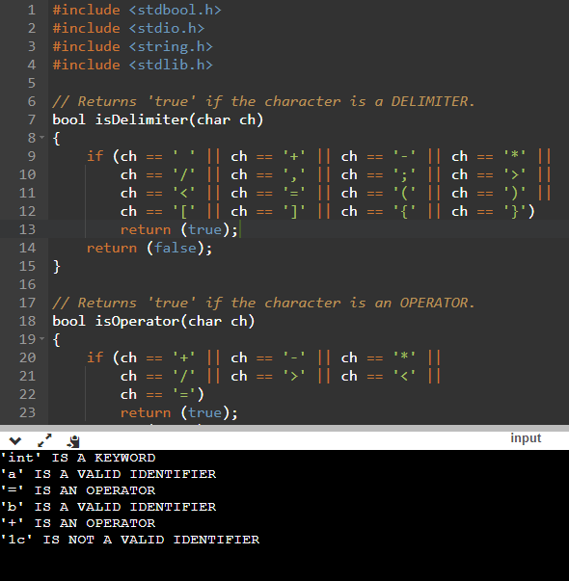

Aim-> Designing a Python Program for NFA and DFA & C PROGRAM TO DETECT TOKENS(LEXICAL ANALYSIS).

NFA code->

from automata.fa.nfa import NFA

nfa = NFA(

states={'q0', 'q1', 'q2'},

input_symbols={'0', '1'},

transitions={

'q0': {'0': {'q1','q0'}, '1': {'q0'}},

'q1': {'1': {'q2'}},

'q2': {}

},

initial_state='q0',

final_states={'q2'}

)

for i in range(1,4):

num = input("Enter the string :")

if(nfa.accepts_input(num)):

print("Accepted")

else:

print("Rejected")

OUTPUT->

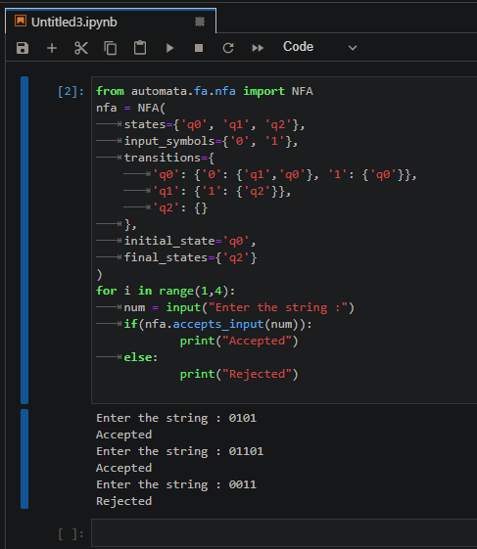

DFA CODE->

from automata.fa.dfa import DFA

dfa = DFA(

states={'q0', 'q1', 'q2', 'q3'},

input_symbols={'0', '1'},

transitions={

'q0': {'0': 'q1', '1': 'q0'},

'q1': {'0': 'q2', '1': 'q0'},

'q2': {'0': 'q2', '1': 'q3'},

'q3': {'0': 'q3', '1': 'q3'}

},

initial_state='q0',

final_states={'q3'}

)

for i in range(1,4):

num = input("Enter the string :")

if(dfa.accepts_input(num)):

print("Accepted")

else:

print("Rejected")

OUTPUT->

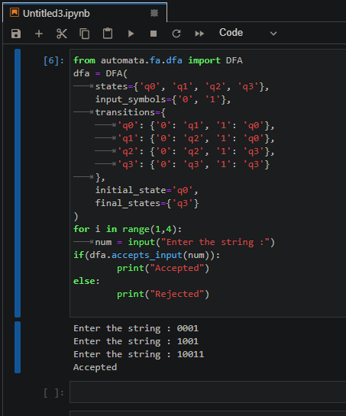

Result->Python program for NFA and DFA was successfully designed and implemented.